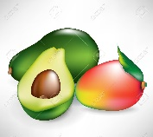

Hello, boys and girls!

I like avocado and mango.

What’s your favourite food?

Draw your favourite food and write sentences.

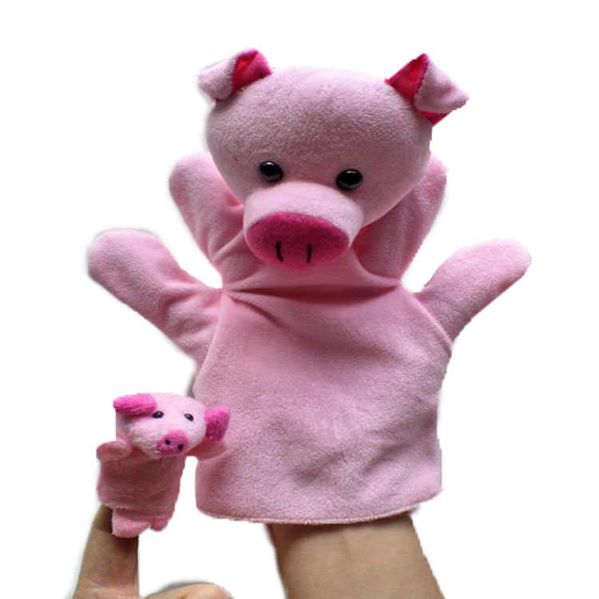



I like_______________________________________________________

_________________________________________________________________________________________________________________________________________________________________________________